# **ENTERPRISE INFORMATION SYSTEM PROJECT**

**Compiled by:**

Adriano brizi - CA277511MQ

Nicky Tubic - 0432103L

Timothy Schembri - 156503L

**Faculty of Economics, Management and Accountancy**

**University of Malta**

**Academic Year 2023/24 - Semester 1**

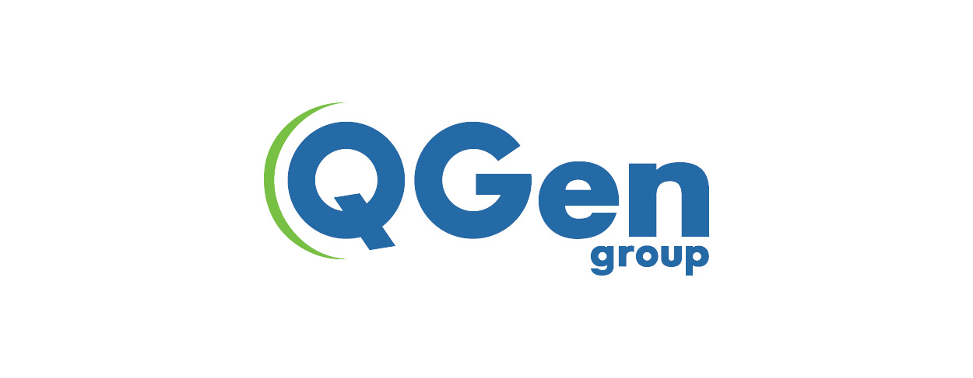 **QGen Malta**

**Table of contents:**

**1. Introduction ..............................................................................3**

**2. Literature Review ....................................................................4**

**3. Overview of the organisation business’s activity...................4**

**4.Problem statement and objective…………………………….5**

**5. Application of Sociotechnical Systems Theory ..................... 6**

**6. Discussion of potential Emerging Technologies .....................12**

**7. Discussion and Analysis ...........................................................15**

**8. Interview……………………………………………………….16**

**9 .Conclusion ................................................................................25**

**10. References ...............................................................................26**

1-Introduction :

In today’s rapidly evolving business landscape, organizations are constantly seeking ways to enhance their operations to remain competitive. The adoption of emerging technologies is often the main key strategy to achieve this goal. Within this context, the relevance of sociotechnical systems theory is a critical framework for understanding the complex interactions that, within an organization, human elements and technology have. Nowadays we are experiencing a shift where fiction is becoming reality. AI is one of the main game changers, which allows businesses to reach results never seen before, mostly in fields such as digital security and fraud monitoring. The need for robust identity verification, risk management and fraud prevention has become paramount and AI could come in handy. This assignment delves into the understanding of business enhancement through a sociotechnical system perspective by implementing emerging technologies, with a focus on an organization that operates in the landscape of Malta, QGen.

The main objective is, as a group, to synthesize theoretical underpinnings with practical applications aiming to create a comprehensive sociotechnical systems framework that will facilitate the integration of AI into the business processes of QGen.

This assignment will follow a multifaceted approach, primarily explaining what is the sociotechnical systems theory in a literature review setting to then continue on an in-depth exposition of QGen and its multiple operations. Here the weak spots that need to be technologically solved will be highlighted. Casting a spotlight on the organization’s industry and its unique role in the compliance sector will give us an ensure solid ground for our subsequent analysis. The understanding of Qgen’s sociotechnical systems theory will be the heart of this assignment. An examination of the company’s operations will be structured by first choosing a specific business activity to then dissecting it through the sociotechnical system lens. This of course will involve an analysis of both the technical and social aspects of the chosen business. Furthermore, we will explore the potential of an implemented AI to optimize QGen’s business perspectives. Our group will craft a cohesive and strategically adopted sociotechnical systems theory that presents a roadmap for the assimilation of AI into the business’s operations. It will be necessary to recognize the need for management strategies while navigating carefully challenged benefits and risks.

The conclusion of this assignment will end with a comprehensive discussion that will synthesize our findings. The discussion will include the importance of a socio-technical system perspective but also shed light on the impact of AI in reshaping QGen’s operational landscape. Our main aim is to equip QGen with the theoretical foundations and insights that are necessary for orchestrating the collaboration between human and technological elements.

2. Literature Review :

The Sociotechnical systems theory is the process of understanding an interplay between technical and social aspects within an organisation. Many businesses might fail due to the fact that the main focus is directly on one of the two aspects, most commonly on the technological side. Any organisational system can only be understood and improved if both ‘social’ and ‘technical’ aspects are brought together and treated as interdependent parts of a complex system. (Faculty of Business, 2023). From what is stated above, there are three key components that build up a sociotechnical system. Technical, social, and the interplay between them.

The technical side is composed of different elements such as the hardware, software, tools, and processes that support any organisation’s operations and alleviates the actual amount of work. These components vary with the constant changing of the surrounding environment and nowadays include advanced technologies such as AI, automation, data analytics, and IoT (Internet of Things).

The social component is all about the people. It includes their roles, the relationships, the way they interact and the organizational structure used to enhance the company's management. Other relevant factors worth mentioning in this component are the attitudes and behaviors that significantly affect a company’s balance as well as the importance of teamwork and communication, vital aspects of the social side.

Subsequently, the interplay between technological and social aspects respectively, which is part of the STS (sociotechnical systems), is useful and relevant in the providing of a meticulous analysis of business activities, due to the fact that it can provide a deep insight into the understanding of the strengths and weaknesses of said firm. (Lucidchart, 2021)

3-Overview of the organization’s business activities

QGen is a firm based on the island of Malta. This firm offers particular different services, one of which is the so-called KYC, ‘Know Your Customer’. QGen’s primary offering as a firm is to help businesses achieve compliance with regulatory requirements. It does so via the elimination of any doubt and ambiguity in relation to who you are doing business with. This methodology enables safer and more hygienic transactions, via the addressing of both safety and corruption issues. Malta has become a center for technologically-oriented businesses, due in part to its advantageous geographical position and regulatory framework.

Both KYC and KYB (know your business) services, respectively improve both the security and safety of firms at large, via the promotion of a deeper understanding of their clientele. QGen is becoming increasingly aware of the disruptive and transformative potential of emergent technologies. Formerly, this firm was a non-technical company that checked all documents primarily by hand. Wishing to automate this monotonous task, they then resorted to the adoption of a more technological approach. QGen provides a comprehensive range of services to assist businesses, startups, and even single people in fulfilling all regulatory requirements. Their demographic is a global one, offering Politically Exposed Person (PEP) and Anti-Money Laundering (AML) checks.

QGen is a part of the Regulatory Technology (RegTech) business. RegTech firms offer technology-driven solutions to assist corporations in successfully and efficiently meeting regulatory compliance obligations. QGen's expertise in KYC fits under this group.

QGen’s service offerings are oriented around the fundamental principles of compliance and identity verification. These include watchlist screening, biometric authentication, document authentication, identity verification, and many more. Among these, identity verification is QGen’s primary focus. This integral service offering enables firms to verify the identities of their partners, clients, and stakeholders. Via this offering, QGen enables its clients to reap benefits like increased security and reduced identity fraud.

QGen caters to a diverse, international demographic. These range from small, family-owned businesses, all the way to large enterprises. Given the global desire for increased understanding of clients, QGen offers their service to both Maltese and international firms. This organization's services are highly customizable, meaning that QGen offers ‘tailor-made’ services to their clients, increasing the effectiveness of their offering alongside net customer equity.

4- Problem statement and objective:

Artificial Intelligence involves the development of software that typically requires human intelligence. QGen, being a business so currently heavily involved in technology, is falling behind in the sector of artificial intelligence. A.I. has seen tremendous growth in recent years. For this reason, QGen must make the adoption and eventual streamlining of A.I. into their workflow as soon as possible, enabling them to remain competitive in the industry, whilst allowing for a better service for their clients. The lack of A.I. integration will inevitably lead to decreased efficiency within the firm. By successfully integrating this transformative technology, QGen may reap several benefits, such as the ability to make data-driven decisions granting them an edge over their competitors and increasing employee equity.

As Business and IT students, our objective is to successfully implement the highly emergent technology that is Artificial Intelligence into QGen’s workflow. We must first identify departments in the firm where AI can have the most impact, then adopt the internal processes within certain business activities to accommodate artificial intelligence. This structured approach will allow for a smooth integration of this innovative technology into the firm. The reasoning behind the implementation of such an emergent technology is to allow QGen to remain competitive in their respective market. This holds especially true given the competitive nature of the technological market QGen finds itself in.

5-Application of sociotechnical systems theory :

The sociotechnical systems theory framework places a heavy emphasis on the dynamic relationship between technical and social elements within a firm. The working of a sociotechnical system is an intersection of multiple features where each one is indispensable for the others to work properly. If one fails, all the remaining systems fall. These main pillars are: The structure , the technology, the people and the process. In this part of the paper we will explain how the firm QGen works, particularly in the activity of online compliance monitoring systems and how it relies on these pillars to successfully be a good competitor in the market.

The Online compliance monitoring service aligns seamlessly with the sociotechnical systems theory, emphasising the interdependence between technology and social components that are part of QGen. We will show how, by breaking it down into pieces, this service can be considered a well built sociotechnical system.

THE TECHNOLOGY

QGen operations have recently switched from a manual to a more technological approach. Building up robust servers and computational infrastructures allowed the company to host the monitoring servers which helped the company achieve a faster paced work and enhanced reliability. For this reason the hardware is providing computational power which provides a protected and unbiased environment for the software to work on. The servers ensure distributed load balancing, which increases availability. The software dictates how the logics and functionalities should communicate between them. This side of the technology allows the company to process regulatory information, helping the conduction of checks and generation of reports to alleviate the workload of QGen’s employees. The network infrastructure is the most complex and critical component of QGen's technological experience. It allows the communication between client’s systems and the company’s servers. The company ensures secure communication protocols, such as HTTPS which ensures the confidentiality and integrity of all data during its transmission. The integrity of data is compulsory due to the company responsibility of following the compliance rules they actually provide. QGen employs Users to navigate through an interface to select specific compliance features they require. The software is developed and maintained by QGen’s technical team which chooses and dictates the logic behind the functionalities of the compliance monitoring service. Regular security audits are conducted to fortify the system against emerging threats.

THE PEOPLE / THE STRUCTURE

Many people are integrated into the process of QGen’s online compliance monitoring. QGen’s hierarchical order cannot really be considered a real hierarchy because it aligns each team with the other, making it possible that each one is interdependent, without differences of power within the business. Everything is based on the end users and their way of browsing QGen’s online platform. By selecting the desired compliance features through its user interface it finally engages in transactions for the service required.

Behind every end user, there is a customer service team that plays a crucial role in their assistance. It addresses queries and provides support for any technical issue, ensuring a smooth customer experience. The end users can communicate with customer service by various means, including live chat, email or phone. It is designed to be responsive and client-focused. Once the complaints are received, the customer service team will address the other business teams for a more insight resolution.

The technical team is the most relevant asset of this business activity. It is responsible for maintaining the system, ensuring its functionality and implementing all different updates. They are directly involved in customer service through the customer service team for any technical issues reported by users. The tech team focuses also on conducting routine maintenance and cooperates with R&D on the development of new features. Their expertise ensures the smooth flow of operations of technical components.

“Sellers” in the compliance monitoring system are third-party entities that provide different features which allow the platform and the company to keep up the pace with a dynamic environment . Such as regulatory research firms can be third-party entities that may be specialised in monitoring and researching regulatory changes , providing updates and insights into changes in compliance requirements, helping the company keep the pace with the evolving regulations. External auditing firms can conduct independent audits to assess the company’s compliance with all regulations. Other third-party entities and maybe the most relevant are the companies that offer compliance related software,tools and platforms.

The organisational structure of the compliance monitoring service is designed to help cohesion and efficiency. Using various departments and teams, this structure makes sure that the business activity is properly working.

**The administration department**: It is composed of key roles directing the company’s strategic aspects. These roles are

* CEO: The leader steering QGen’s overall decision-making and directions.
* HR: Manages human resources such as recruitment , employee relations and performance
* Accounting: Handles financial matters, budgets and financial reports

**Agents department**: This department focuses on the actual operation of compliance, leading all the teams to complete their specific functions.

* Compliance team: Executes compliance checks while ensuring adherence to all the regulatory standards.
* Compliance rules team: Develops and updates the compliance rules which change dynamically with the business world.
* Fraud detection team: Specialised in detecting fraudulent activities and avoid it.

**Technology Team**: Playing a key role in the development and maintenance of QGen’s Online compliance solution.

* Software development: is responsible of creating, maintaining and updating the compliance monitoring software.
* Cloud infrastructure team: Managing the storage and the security of compliance data in the cloud infrastructure.
* Tech and communication team: Implementation of different tools to allow good communication such as Gyra, Office and Slack and its maintenance.

**Support team / Customer service:** Ensures the satisfaction of customers and employees and this actually plays a crucial role by keeping all communication balanced inside the company itself.

* Onboarding support: Addresses and resolves all issues which are raised by anyone inside the company, and provide insights gathered from clients into system functionality
* Customer support: Specified for any issue raised by customers.

**Sales Team / Accounting :** Is engaged in client acquisition and retention, highly relevant to make sure that customers continue interacting with the company.

* Sales Representative: are the ones who engage with all potential clients and close all deals.
* Client Relations: Do all the possible to maintain relationships with existing clients , ensuring all satisfaction and addressing the different complaints.

THE PROCESS

The process evolves in the concept of how Qgen company works and all the different steps it goes through when a customer requests to Qgen’s online platform a KYC system for a certain purpose. The below attached diagram shows all different stages that are relevant to the understanding of how end users act with this business activity. As a sociotechnical system we can see that each department equally dependence from the others, and in this activity the involved teams are the compliance, technology, accounting and human resources.The first step consists of the analysis of the customer choices towards the compliance features given by the business in the Online compliance monitoring system and the collection of all customer information from the compliance team to have a wider idea of the customer preferences. The information will be acquired directly from the Online platform however, if required ,the compiance team will send an additional email to clarify certain aspects. Subsequently, the tehchnolgy team will input all gathered info into the business database, which will help the process of estimation for building the required KYC system. At the same time the accounting department estimates the costs of production. Behind the structured communication of the business teams and their collaboration there is the HR team which ensures that all employees are competent for such request. If the competency does not reach the company standards, HR provides courses for the purpose of employee training.Once the account’s estimation of costs is done, the compliance department makes sure that the costs and the terms and conditions align with the customer requests. If the customer does not accept, some fees might apply for the work done and the service comes to an end. On the other hand, if the customer agrees with what requested, the tech team begins building the KYC system while the ledger is updated with the operational costs by the accounting department. During the building process, compliance once more contacts the customer to have do a real time double checking on what are the requirements that the user needs and the purpose of it, so to make sure the satisfaction is achieved.Once more the teach team adjourns the system with the latest information so to finalise it, while the compliance focuses on the optimal respect of laws and the customer approval on the system’s capabilities. Finally, if the end user sees that something is still needed for the KYC system he contacts compliance which goes through the last steps with the tech teams to fix what is unconventional. To conclude, the accounting team will fix and conclude all payments, ending the process of provision of the KYC system.

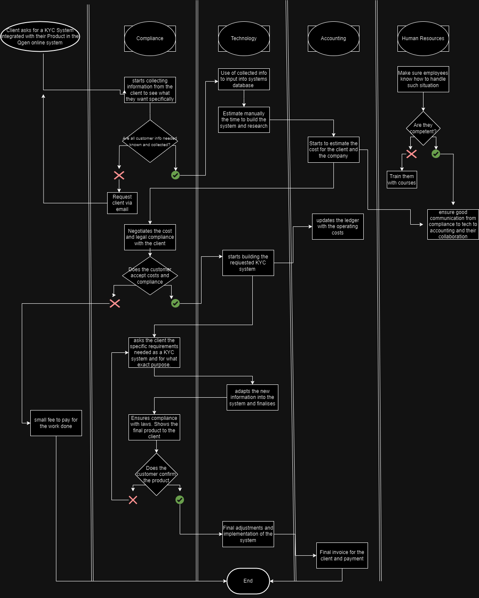

THE INTERACTIONS BETWEEN TECHNICAL AND SOCIAL COMPONENTS

Within the operational framework of QGen the mutually reinforcing interactions between the technological and social components are critical to determining the organisation's overall effectiveness. In the technical sphere, QGen depends on highly developed technological systems to provide KYC services such as document authentication and identity verification. This means that different software programs and tools must coordinate and communicate with one other seamlessly in order to ensure that data flows through the technical infrastructure effectively. Concurrently, on the social front, QGen's diverse teams—which include developers, compliance specialists, and customer support representatives-place a high value on efficient communication. After the covid-19 pandemic, Qgen improved the communication systems by implementing apps such as Gyra, Office and Slack that changed the way the business collaborated between each other. With the human aspect, open and transparent communication guarantees a common understanding of responsibilities, promotes teamwork and eventually improves the provision of KYC services. Technical coordination is the process of combining several modules, keeping them compatible and making sure that QGen's technology infrastructure functions as a whole. The coordinating element, which includes both human and technical components, is just as important. In order to connect technological systems with more general company objectives and regulatory norms, social coordination requires cross-departmental collaboration in areas including software development, compliance and customer service. An essential component of all domains is decision-making, which comprises both human and technological decisions about compliance, corporate strategy and client contacts. Technological decisions are related to software development processes and the adoption of emerging tools. Understanding how important it is for workers to be involved, QGen regularly involves its staff in technical conversations and decision-making, creating an environment where social and technical elements are constantly influencing and learning from one another. Mechanisms for collecting and analysing system performance measurements, compliance audit results and user experience data are examples of feedback loops in the technical domain. Conversely, social feedback loops include avenues for staff members to communicate, report problems and offer ideas for improving processes. Additionally, QGen makes investments in technical and social training programs to guarantee that staff members are up to date on the most recent advancements in KYC, emerging technology and compliance procedures. The complex interactions between QGen's technological and social aspects essentially reflect the ideas of sociotechnical systems theory, highlighting the critical role that efficient coordination, communication, and decision-making play in the delivery of safe and dependable KYC services.

SOCIOTECHNICAL DISADVANTAGES

The sociotechnical systems described above surely provide a comprehensive framework for Qgen’s online compliance monitoring service. However, since QGen has recently switched from a more manual approach to a better understanding of the technological world, there are still potential disadvantages which could be solved by implementing multiple disruptive technologies.

Human error and time efficiency are two of the most common fears of a business activity. Since making mistakes is human, all businesses take into consideration this possibility. However no mistakes means less costs, which would increase Qgen’s GDP pivot table. The main disadvantage about the online compliance monitoring system is the lack of atomisation which, with todays business environment, is particularly needed to not be left behind. The idea of atomisation and disruptive technology would focus on the resolution of issues such as lack of communication and coordination, resource allocation, scalability as well as a more enhanced capability to adapt to emerging technologies.

6-Discussion of potential emerging technologies :

The technological field is a rapidly evolving one. Staying ahead of the curve in such a field is crucial for a firm like QGen, one that is heavily entrenched in technology. The following are various emergent technologies and their respective potential benefits, in relation to QGen.

Artificial intelligence involves algorithms conducting analysis on a large amount of data. This is done in order to acknowledge patterns in said data. Within the context of QGen, artificial intelligence, alongside machine learning, may be utilised in order to streamline the customer verification process, alongside the extraction of relevant information from documents and the flagging of dubious and suspicious activity. Blockchain Technology allows for the storing of data in a decentralised ledger . In the context of our firm, this could include customer data, translation records and identity verification. This enables security, transparency and tamper resistance, values that are crucial to our firm's bottom line.

A particular application of Artificial Intelligence that may be applied into QGen’s workflow is an automated compliance monitoring system. This service is meant to help the business stay updated with the constantly evolving compliance regulations. This service would allow an easier and proactive approach to the compliance

Robotic Process Automation is a relevant and emergent technology that may prove useful to QGen. RPA entails the utilisation of software ‘bots’ in order to automate repetitive tasks, particularly those that are rule-oriented. Within the context of QGen, RPA allows for the processing of documents, validation of customer information and lastly, the cross referencing of data. Biometric Authentication is a crucial emergent technology that is sure to prove useful to QGen. This technology enables users to be authenticated via their unique characteristics. In relation to QGen’s ‘know your customer’ business model, this ensures that individuals match their submitted documents. Furthermore, upon successfully integrating this groundbreaking technology, QGen may experience increased security, reduced risk of identity theft and a hastier identity verification process.

Lastly, Big Data Analytics enables the leveraging of large datasets in order to identify emergent trends, make informed decisions and to conduct risk assessment. QGen may use this technology to perform customer due diligence and to aid in risk profiling. Other benefits include data-driven decision making and better customer segregation.

In order to reap the benefits of these highly emergent technologies, management strategies must be employed. These must differ between each technology to ensure successful integration of each one.

Artificial intelligence poses challenges, including privacy concerns and the quality of data provided. It may also pose a challenge to integrate into existing systems. Robust data security measures may be set in place in order to prevent such concerns. Compliance with data protection regulations must also be observed at all times. Blockchain Technology may also present challenges upon its integration into QGens workflow. These challenges include its initial setup costs, alongside regulatory compliance. A continuous monitoring of the blockchain infrastructure at large is key to controlling such a decisive, emergent technology. If employees comply with regulatory requirements, QGen may reap the benefits of such a technology, including data integrity and reduced incidents of fraud.

Biometric Authentication may enable QGen to offer a streamlined verification process, alongside improved security. This however, is at the cost of privacy of biometric data and ethical considerations. As with all other emergent technologies, a careful compliance with ethical guidelines and data protection laws should be considered standard. When looking to implement Robotic Process Automation into its workflow, QGen may face challenges such as its initial implementation costs, alongside potential jobs displaced after the fact. The firm must ensure that all its employees are sufficiently trained to work alongside RPA systems. This will minimise job displacement within the firm.

Some challenges QGen may face when implementing Big Data Analytics are talent acquisition and data volume/quality. Upon dealing with such an intricate technology, QGen must ensure the sufficient building of a skilled analytics team, along with a substantial investment in the providing of quality data.This will enable the firm to reap the benefits of this emergent technology, including the acquisition of data driven insights and heightened risk assessment.

One particular application of an emerging technology that may realistically be implemented into QGen’s workflow is that of an automated compliance monitoring system .This may allow the firm to remain up to date and compliant with the ever-evolving industry regulations. This practical integration of A.I. into QGen’s workflow will enable the firm to position itself in a proactive manner, resulting in increased compliance.

An automated compliance monitoring system consists of many prominent features. Firstly, it enables QGen to perform real-time compliance checks. This system may monitor changes in regulatory compliance. These automated checks may be performed in real time. QGen may also utilise this service in order to perform customised compliance checks, based on each individual client. Another key feature to be considered is that of the automation of reporting and subsequent documentation. This novel system may create automated compliance reports for QGen. These may entail their current status and any further action that needs to be taken. The automation of compliance documentation saves time, whilst simultaneously reducing the risk of manual error. Lastly, this system may also alert the firm in relation to upcoming regulatory changes. This will ensure the firm has enough time to act accordingly.

There are a plethora of benefits that may result from the integration of an automated compliance monitoring system into QGen’s workflow. QGen may experience increased efficiency, due not needing to concern themselves as much with the ever changing regulations of the industry. This novel system may also provide risk mitigation, as the real-time monitoring aspect of the system reduces the risk of non-compliance. This allows the firm to avoid potential financial and legal consequences. The automation of documentation saves time, allowing for an adequate optimization of resources. However the application of this technology has to be scrupulously analysed. The process of asking and including employees in this decision is a must so as to avoid complications that may arise once applied without a certain consent. Via the introduction of this business activity, QGen may leverage its expertise in KYC, KYB, and compliance to offer a valuable service that addresses a critical need for businesses in a constantly changing regulatory landscape.

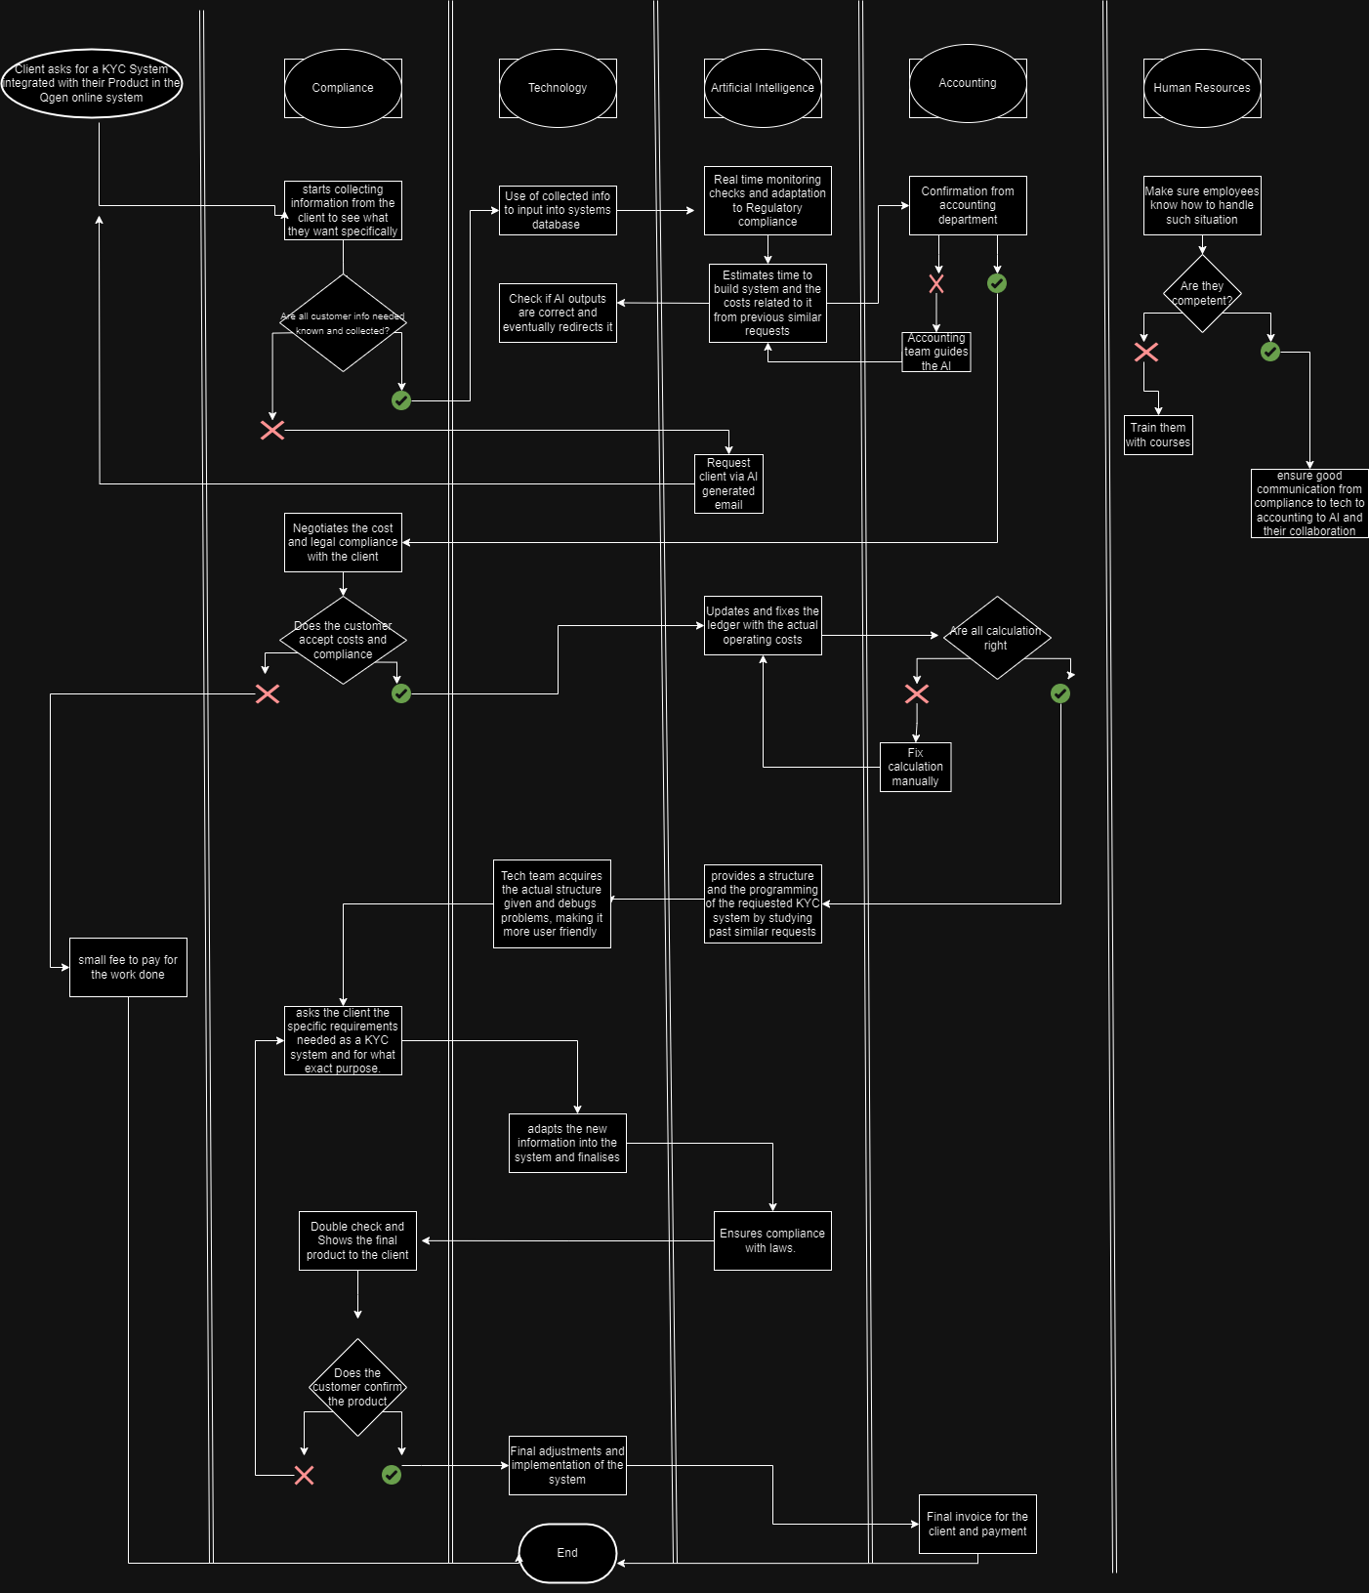

7- Discussion and Analysis

Once applied the disruptive technology into Qgen’s Online compliance monitoring system, the company’s competitive advantage takes a turn. As it is possible to analyze, comparing the first diagram to the second, AI is used as a tool to enhance and allow teams to communicate better and ensure that each information and service provided is close to perfection. In the above diagram, AI was placed in a middle swimlane to show how every action passes through the Intelligence and vice versa. It is compulsory to constantly check the output given by this technology, for this reason each team focuses on receiving the created information, analyze it, fix it if necessary and then send it to the next step. We can see how it allows Qgen to have more secure outputs and an increase paced in the work flow. This, other than allowing the company to be ahead of the competition, it makes sure that no customer is deluded with all services provided. The question that might raise spontaneously is, how would this AI impact the people’s work? Will it replace the employees job? The answer is that AI will only generate new opportunities. In the case of employees, most will keep their job and will have to learn to go along with such innovative technology. This will be possible by providing courses and constant updating on this topic.

Finally, if applied, AI could be revolutionary towards the sociotechnical system of Qgen’s business. Qgen’s automated compliance online system would be the base and maybe the example for the compliance industry and the surrounding world, which, by being so innovative, could be a game changer on how businesses of this industry will see the collaboration between the technology and the social.

7 - Interview

**Interviewer**

Okay, so go ahead. Thank you for agreeing to participate in this interview. My objective is to understand more about QGen and its operational practices. Your insights will be helpful for my assignment, and I assure you all the information provided will be treated with the utmost confidentiality. Could you please briefly introduce yourself and describe your current role in the organisation?

**Godwin Schembri**

And you want to understand about QGEN?

**Interviewer**

Yes.

**Godwin Schembri**

Okay, so about QGen. Qgen has been established since 2006. It started as a back-office operation to do KYC and compliance. And in the last couple of years, it also became a technology company. So before it was receiving KYC documents, mostly via mail or APIs, agents would be manually reviewing this information, verifying the documentation sent, and verifying that it matches the expected identity. We also do especially know your business, meaning that we find out about companies, who owns them, what we refer to as the ultimate beneficial owners, and the directors. We do sanction checks, which has become really critical at the moment, and pep checks to identify if they are run by anyone involved in politics, what we call politically exposed people. The last few years, the company has been redirected towards a more technological company, and it's been building software in order to also help with the compliance aspect. Still, we have built a cloud solution that allows users of the software to send us the documents. Still, however, our agents review the documents, but then are able to set the status, upload even more documents that they find from third-party portals, or in some cases, refer back to the customer needing more information.

**Godwin Schembri**

Now we're moving on towards automating some of this aspect. About my role?

**Interviewer**

Yes, I was going to ask you, how long have you been working with Qgen?

**Godwin Schembri**

I've been working with Qgen for the last six years.

**Interviewer**

Let's talk a bit about your history. Is this your first role as a manager? No. What are the main responsibilities associated with your role?

**Godwin Schembri**

Yes, as Chief Technology Officer, I am responsible for all aspects related to technology. That means from procuring equipment to security. But today, these aspects are more and more packaged and outsourced. More and more we are involved in software development. So mostly my day to day is relating to recruiting software developers, training them, mentoring them, and of course, designing the software that will be built into the solution.

**Interviewer**

Could you please provide a brief interview over the different departments within the organisation, and more importantly, how they interact and communicate with each other?

**Godwin Schembri**

Brief interview, what do you mean?

**Interviewer**

Brief overview, sorry.

**Godwin Schembri**

Could you provide a brief overview of?

**Interviewer**

The different departments within the organisation?

**Godwin Schembri**

Yes, the company is fairly small. The main areas are, of course, administration, which encompasses the CEO and HR and accounts. Then the other area is the agents, the compliance team, which effectively are trade agents and understanding compliance rules and are able to look for fraud and identity verification. Then there is my team, which is technology.

**Interviewer**

Okay, thank you. Could you please specify an outcome or goal that your department works on, focuses on?

**Godwin Schembri**

The main one is building the software as a solution called QGen Online. We soft launched it about a year ago, but with minimal functionality, with small users using limited features of the system. We have continued to build a lot of features, and we intend to launch it at the beginning of next year. The main goal now is to have a lot of features, the main one being automated verification.

**Interviewer**

What tools, technologies or systems does your apartment use to achieve this outcome?

**Godwin Schembri**

Okay, so we develop the software ourselves. If you're talking about software development, we're talking about languages. I don't think you're interested in that you're interested in that. We, of course, deploy everything on the cloud using AWS. Maybe the interesting part would relate besides developing everything ourselves, we then, of course, rely on third-party libraries. When it comes to automation, we will be using some machine learning tools because we'll be using AI. And when it comes to team tools, we use Jira, we use, of course, Office, we use Slack, if that is what you're asking.

**Interviewer**

Who are the main stakeholders in this process and how do you coordinate with them?

**Godwin Schembri**

Okay, the main stakeholders are, of course, the company owners who have set out a vision to create this automation tool for compliance, or rather to create a compliance solution with automation to be sold globally for use by companies that need to achieve compliance. The stakeholders within this scenario are there for the owners, my team, our agents, who are mostly involved even with automation, in checking some referred documents, our clients, and our clients.

**Interviewer**

Could you describe a situation where coordination between different departments or teams was essential for the successful completion of an activity related to the outcome?

**Godwin Schembri**

Well, I think the easiest example of cooperation is when you are onboarding a new client. The new client will have questions about the system and about compliance, or rather from a compliance point of view. If he's talking to my team alone, we will be describing how the system works, but not necessarily saying how it's going to solve his compliance needs. In that scenario, we'll want to involve the agents themselves who understand his process, understand his need for verification, and we'll tell him how we do that as well. There's ourselves explaining how this technology is used, the agents will explain how the full process is completed, and of course, the sales team who first approach the prospect and then close the deal by, of course, signing the agreements, offer the pricing, all areas that we and the agents are not involved in.

**Interviewer**

In your professional opinion, how well do the technological tools and systems align with the needs and requirements of your employees?

**Godwin Schembri**

What do you mean?

**Interviewer**

For example, are the tools up to standard? For example, would you need to upgrade, adapt modern technology or new emerging technologies?

**Godwin Schembri**

Okay, we're talking about the operational tools required to manage what we do. If it is Slack, if it is Office, if it is Teams, I think we are well equipped. We also use a third-party system in order to get information. At the moment, I don't think we have any pain around them now.

**Interviewer**

How often do your teams undergo training or upskilling sessions to adapt to new technologies or systems?

**Godwin Schembri**

Well, my team being in technology are given time during the month in our reviews when we identify new technologies so that they get trained. We ask them to do Udemy or read on specific technologies, give them time during office time in order to read. We give them research time in order to then propose a solution using the technology we aim to use. We also then, once a year, try to give them other typeof training not directly related to technology, either in leadership skills or in soft skills, and in some cases, around security. Today, there's mandatory training required of all your staff that they are well aware of GDPR and security minimum rules in order to ensure that the company strictly adds to these rules.

**Interviewer**

Okay, thank you. And are there specific communication channels established for discussing and resolving technical issues or challenges?

**Godwin Schembri**

Yes, of course. There's an internal ticketing system where issues can be raised by anyone within the company and they are referred to our support team who will look into the matter and immediately respond back to the user giving them information either. With a solution. Or else if it requires different skills than the person at the support, the support team will refer back to the user that it is being tackled and the meantime internally refer it to the skilled resource that potentially can resolve the matter.

**Interviewer**

Of course. And how does QGEN adapt to the industry trends or changes in regulations?

**Godwin Schembri**

Well, that's our industry, right? Regulation definitely must be our strength. It is our strength. And therefore, we have our compliance team, who is constantly monitoring the general global trends around GDPR, around anti money laundering and fraud and risk and identity theft.

**Interviewer**

Thank you. And are there any specific external factors that have recently influenced the way your department operates? Like, for example, the Blacklisting relisting sorry and so on?

**Godwin Schembri**

Can you repeat that, please?

**Interviewer**

Are there any specific external factors that have recently influenced the way your department operates?

**Godwin Schembri**

External factors that have recently affected how my department operates, for example, the war.

**Interviewer**

Ukraine, Palestinian, Israeli conflict, so on and so forth.

**Godwin Schembri**

I think the one that has really impacted us is the COVID So, before COVID we used to recruit locally, insist actually, that we recruit locally. We would, even though as hard as it is to find certain skilled resources in the technologies we use, we would pay eventually, we might recruit globally, but we insist that within six to eight months, they relocate to Malta. And we always had an office, and all the team is office based. The way we operate meant that we are constantly calling for meetings, face to face meetings. We would have many meetings on a daily basis now, with hindsight, potentially with unnecessary meetings, sometimes. So COVID, of course, after putting us all working from home, made us realise that we could potentially recruit and keep our resources remote. And that's what we did today as we went back to our offices. We have more than 50% of our team made up of completely remote employees that cannot make it to the office because they're globally, they're physically not in Malta. And even if we are in an office where three or five members are in the office, the meeting still is held online because the other team members are joining online.

**Godwin Schembri**

Therefore, the tools for meetings and the way of organising ourselves has dramatically changed. Before COVID and to after COVID.

**Interviewer**

Thank you. Have there been any significant changes to your department's business activities due to technological advancements or the implementation of a new system?

**Godwin Schembri**

Well, my department specifically is technology. So although solving the way of automatically verifying the documents by looking around for better libraries in identifying the identity documents, whether being fraudulent documents or being realistic, and, of course, our liveness checks of people when taking selfies.

**Interviewer**

Thank you. Were you involved in the decision making design of that change into implementing them?

**Godwin Schembri**

Yes, absolutely.

**Interviewer**

And how did you or your team contribute to the design implementation process completely? What challenges, if any, did you sorry, what challenges, if any, did your team face during the transition, and how were they addressed?

**Godwin Schembri**

Training. You're changing and technologies. You have to train people in these technologies. You have to change designs, but they are more than challenges. They are challenges, but they are part and parcel of what we do. So nothing different. It's our job rather than a challenge.

**Interviewer**

Okay. Thank you very much. This concludes the interview. Thank you for your time.

**Godwin Schembri**

Okay.

**Interviewer**

It's all right. Thank you.

**Interview’s Summary:**

Godwin Schembri is the Chief technical officer at QGen and has been working with the company for 6 years. Alongside his previous experience, he has also held the managerial position in other firms in the past. He has had various management positions within many technology related companies. At QGen he is responsible for all aspects related to technology within the company. The main mission at QGen is providing companies with KYC technology to verify the customers that they deal with. QGen is a small to medium sized company so there are various departments like technology, human resources, accounting and compliance and they communicate between them using Slack. The output of the company is the software that they sell to companies. Godwin works in the technology department so he is incharge of the production of software from concept to implementation. Slack, GIRA, Microsoft office, AWS and Third party libraries are used to create the software. The main stakeholders are the company owners. When a client asks for any additions the departments communicate between themselves to make sure they implement the ask accordingly. The tools are sufficient and up to standard. The technology team is given some allocated time during the month to learn and adapt to new and emerging technologies in order to stay competitive and or to learn new skills using learning sites like udemy. They also receive other training not necessarily tied to technology like security and leadership skills. They have an internal ticketing system to resolve technical issues etc. Gdpr, money laundering and identity theft are regulations that QGen has had to adapt to. Covid was a big hit to how the company operates regarding external factors. Since technology is always changing a lot of systems are being implemented in the department and since Godwin is the head of the department he was involved in designing, contributing, implementing, training and dealing with all of the challenges.

9 - Conclusion

In the modern era, any firm that fails to adapt to emerging technologies will be left behind. This statement holds true to QGen. Due to the intricate nature of the service offered by said firm, this being KYC (know your customer), it is of utmost importance that QGen incorporates emerging technologies such as Artificial Intelligence into their workflow. This will allow the firm to remain current in relation to their competitors in the market. This is especially important due to the nature of QGen’s demographic, that being an international one. This broad spectrum of potential clients entails that QGen’s competition also spans the global market. Competing against an international league of competitors forces the aforementioned firm to use every tool at their disposal in order to maximise output and customer equity. The integration of artificial intelligence into their workforce will streamline the monotonous, repetitive work typically associated with firms offering a KYC service. This, in turn, will lead to increased output and efficiency within the firm, resulting in an increase in net customer satisfaction. Customer satisfaction ultimately being QGen’s bottom line, this novel partnership between this firm and this highly emergent technology, will be sure to bear good fruit for our firm in both the near and distant future.

References

- Faculty of Business (2023). *Socio-technical systems theory*. [online] Leeds.ac.uk. Available at: https://business.leeds.ac.uk/research-stc/doc/socio-technical-systems-theory#:~:text=Socio%2Dtechnical%20theory%20has%20at,parts%20of%20a%20complex%20system. [Accessed 29 Oct. 2023].

- Lucidchart. (2021). *The Importance of Sociotechnical Systems*. [online] Available at: https://www.lucidchart.com/blog/sociotechnical-systems [Accessed 29 Oct. 2023].